Week No: 1 | Roll Number: 23071A05B0 | Date: 20|1|26
Week 1 Title: Data Handling Functions
Aim: To implement Data Handling Functions.
Program/Output:
import pandas as pd
df=pd.read_csv("D:\\VJIET\\CSE\\data1.csv")
df
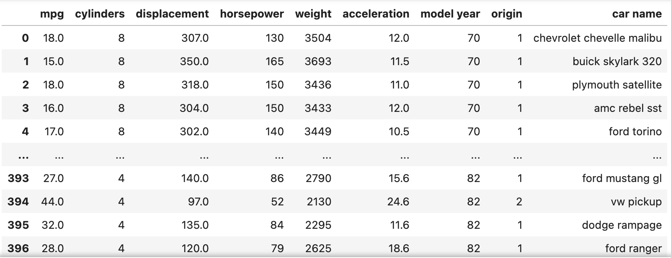
df.shape
(398, 9)

df.columns
Index(['mpg', 'cylinders', 'displacement', 'horsepower', 'weight',
'acceleration', 'model year', 'origin', 'car name'],
dtype='object')

df.tail()
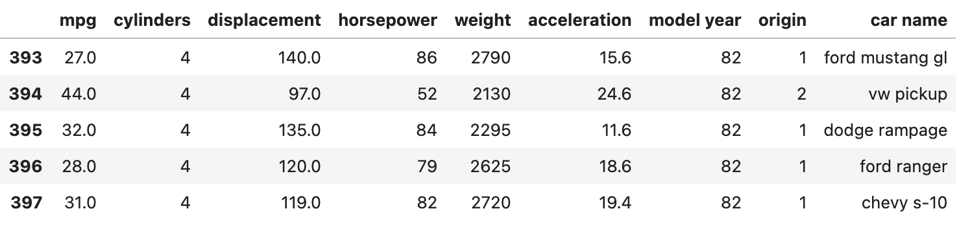

df.rename(columns={"model year":"year"})
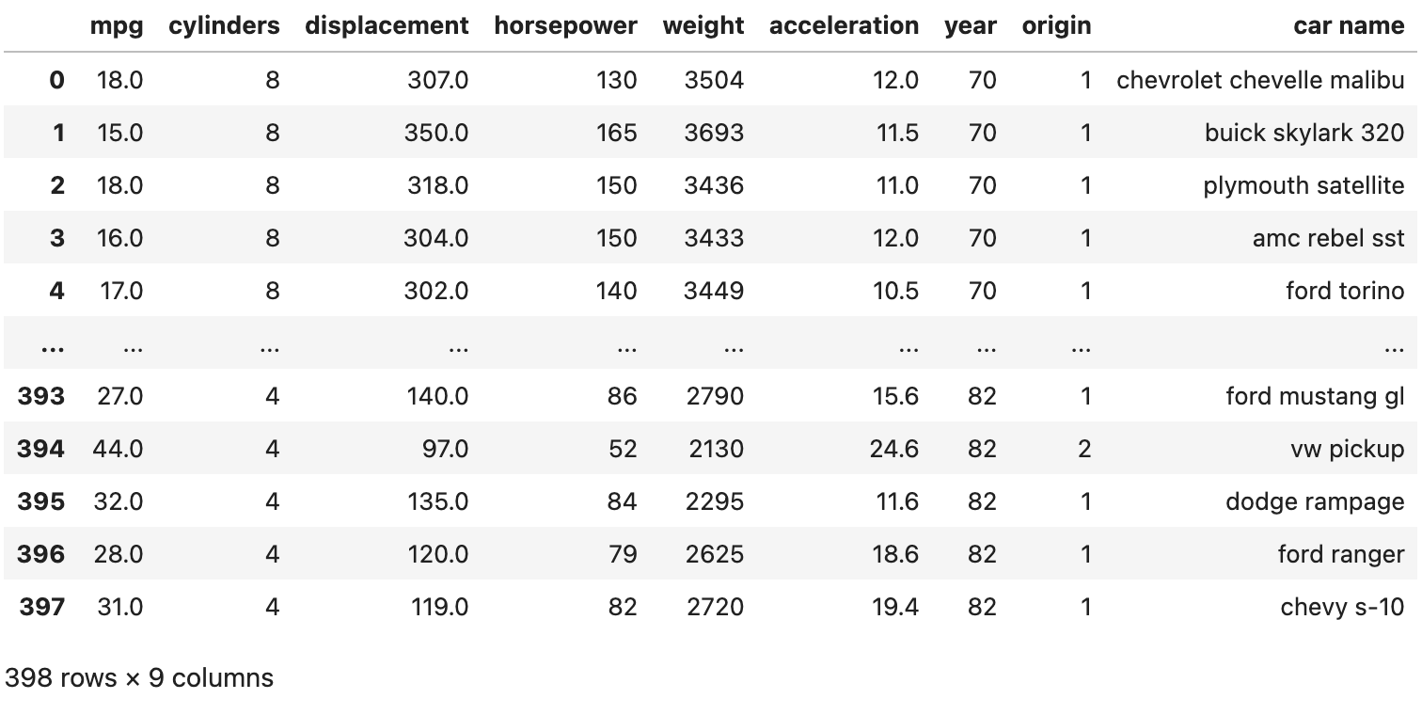

df['origin']
0 1
1 1
2 1
3 1
4 1
..
393 1
394 2
395 1
396 1
397 1
Name: origin, Length: 398, dtype: int64

#bind sets of rows of data frame
df1=df2=df
df3=pd.concat([df1,df2]).reset_index(drop=True)
df3
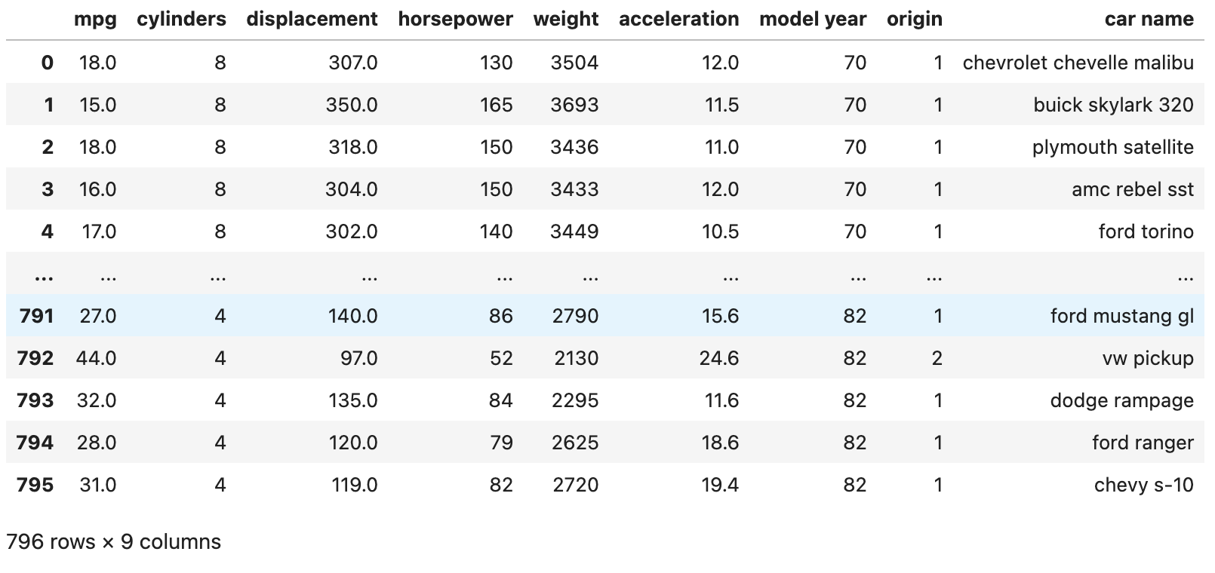

#bind sets of columns of data frame
df1=df2=df
df3=pd.concat([df1,df2],axis=1).reset_index(drop=True)
df3
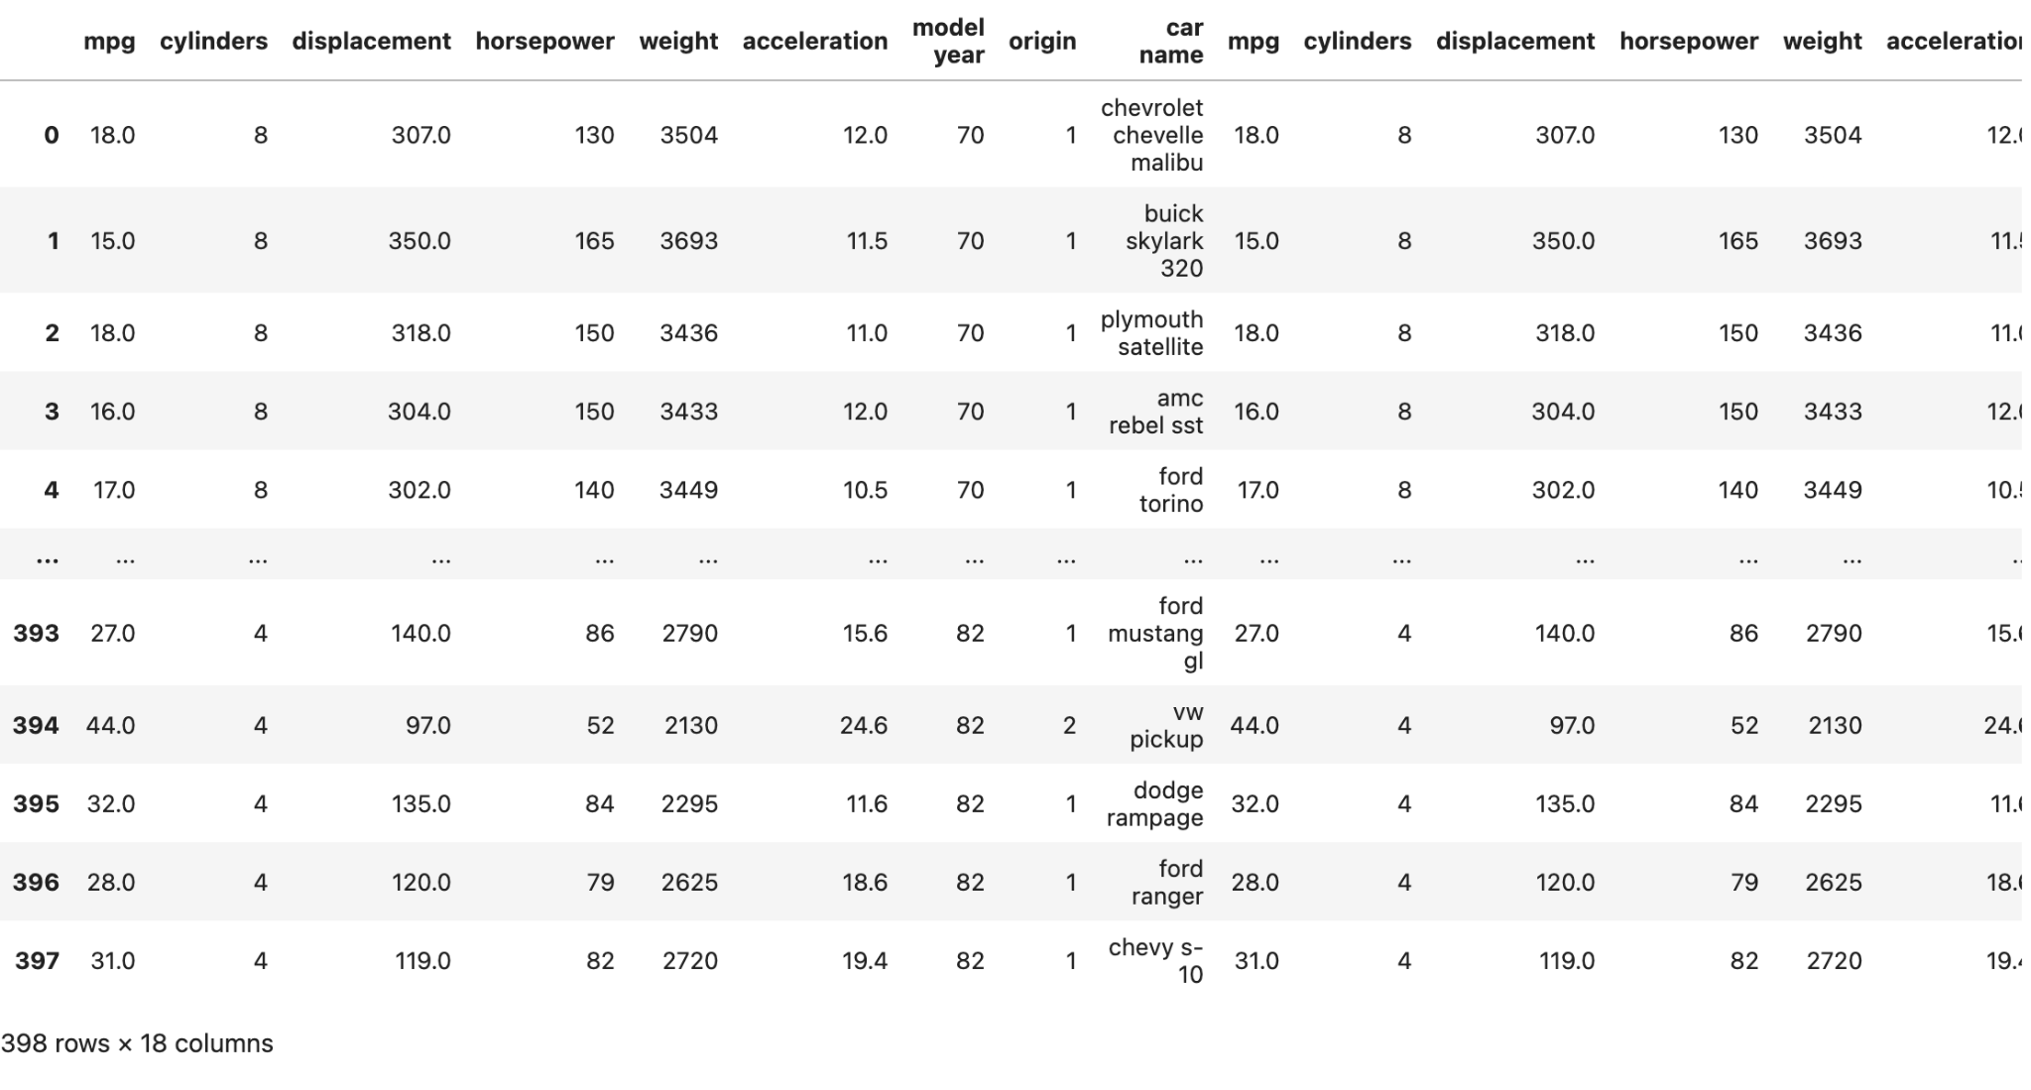

#find missing values
df.isnull()
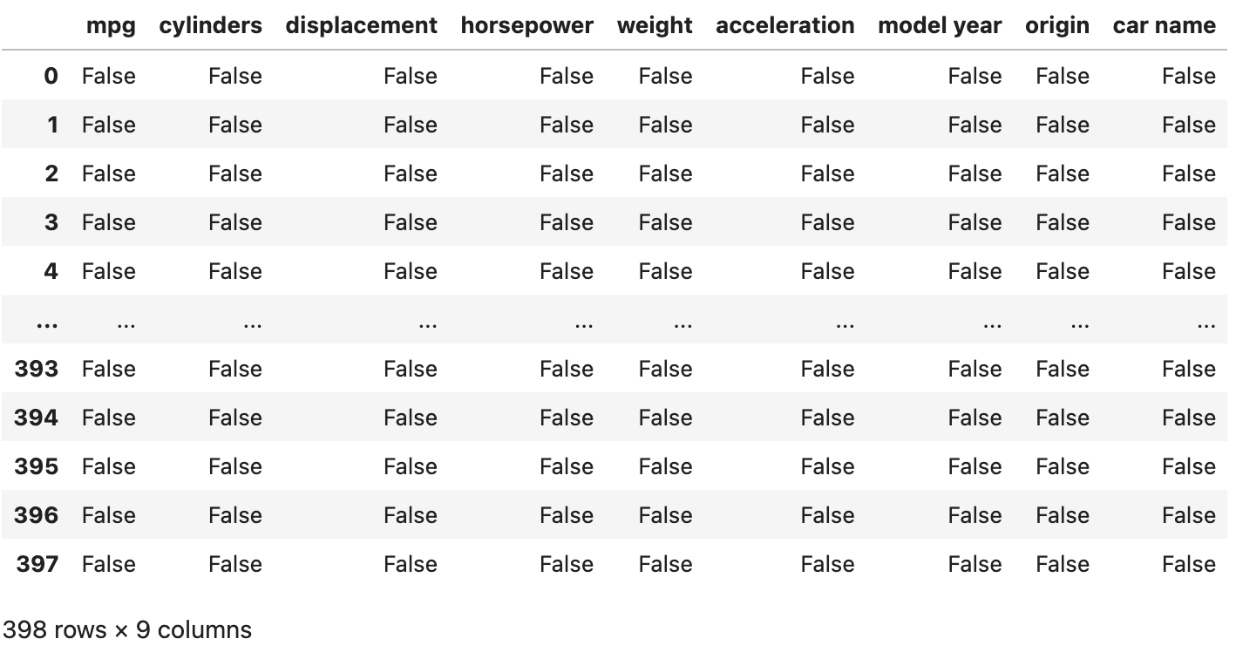

df.isnull().sum()
mpg 0
cylinders 0
displacement 0
horsepower 0
weight 0
acceleration 0
model year 0
origin 0
car name 0
dtype: int64

Week No: 2 | Roll Number: 23071A05B0 | Date: 27|1|26
Week 2 Title: Basic Statistical Functions for Data Exploration
Aim: To implement Basic Statistical Functions for Data Exploration
Program/Output:
import pandas as pd
import matplotlib.pyplot as plt
import seaborn as sns
from statistics import median
df=pd.read_csv('E:\\VNR-VJIET\\DE\\datasets\\auto-mpg.csv')
df
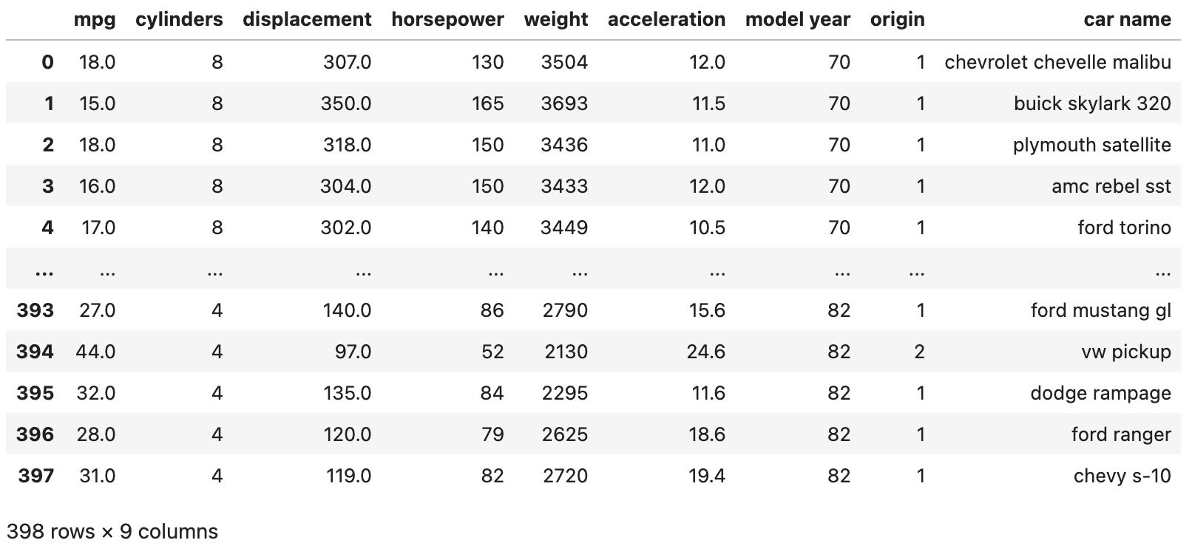

#mean of displacemnet
df['displacement'].mean()
193.42587939698493

#median of displacemnet
df['displacement'].median()
148.5

#mode of displacemnet
df['displacement'].mode()
0 97.0
dtype: float64

df['displacement'].value_counts()
97.0 21
98.0 18
350.0 18
318.0 17
250.0 17
..
104.0 1
110.0 1
130.0 1
111.0 1
144.0 1
Name: displacement, Length: 82, dtype: int64

# Measure of dataspread, standard deviation, Quartiles, IQRD
df.describe()
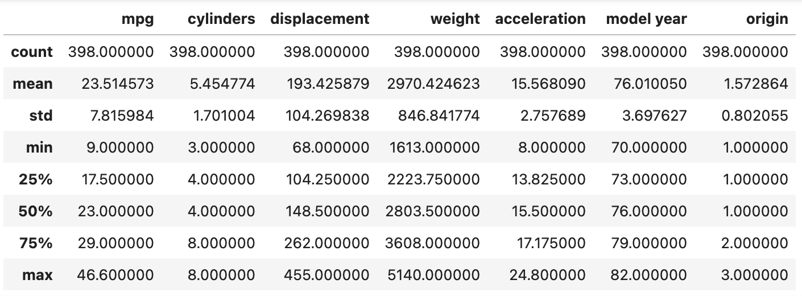

df.std()
mpg 7.815984
cylinders 1.701004
displacement 104.269838
weight 846.841774
acceleration 2.757689
model year 3.697627
origin 0.802055
dtype: float64

# finding variances of all columns
columns=['mpg', 'cylinders', 'displacement', 'weight',
'acceleration', 'model year', 'origin']
print('Variances of each column')
for col in columns:
print(df[col].var())
Variances of each column
61.089610774274405
2.8934154399199943
10872.199152247364
717140.9905256768
7.604848233611381
13.672442818627143
0.6432920268850575

# finding standard deviations of all columns
print('standard deviations of each column')
for col in columns:
print(df[col].std())
standard deviations of each column
7.815984312565782
1.7010042445332094
104.26983817119581
846.8417741973271
2.7576889298126757
3.697626646732623
0.8020548777266163

#Quartile
import numpy as np
q1=np.percentile(df['displacement'],25,interpolation='midpoint')
q2=np.percentile(df['displacement'],50,interpolation='midpoint')
q3=np.percentile(df['displacement'],75,interpolation='midpoint')
IQR=q3-q1

print(q1)
104.5

print(q2)
148.5

print(q3)
262.0

print(IQR)
157.5

q11=df['displacement'].quantile(0.25)
q11
104.25

q33=df['displacement'].quantile(0.75)
q33
262.0

Week No: 3 | Roll Number: 23071A05B0 | Date: 3|2|26
Week 3 Title: Plotting Graphs
Aim: To plot graphs to better visualise the dataset
Program/Output:
import pandas as pd
import matplotlib.pyplot as plt
import seaborn as sns
from statistics import median
df=pd.read_csv("C:\\iris.csv")
df
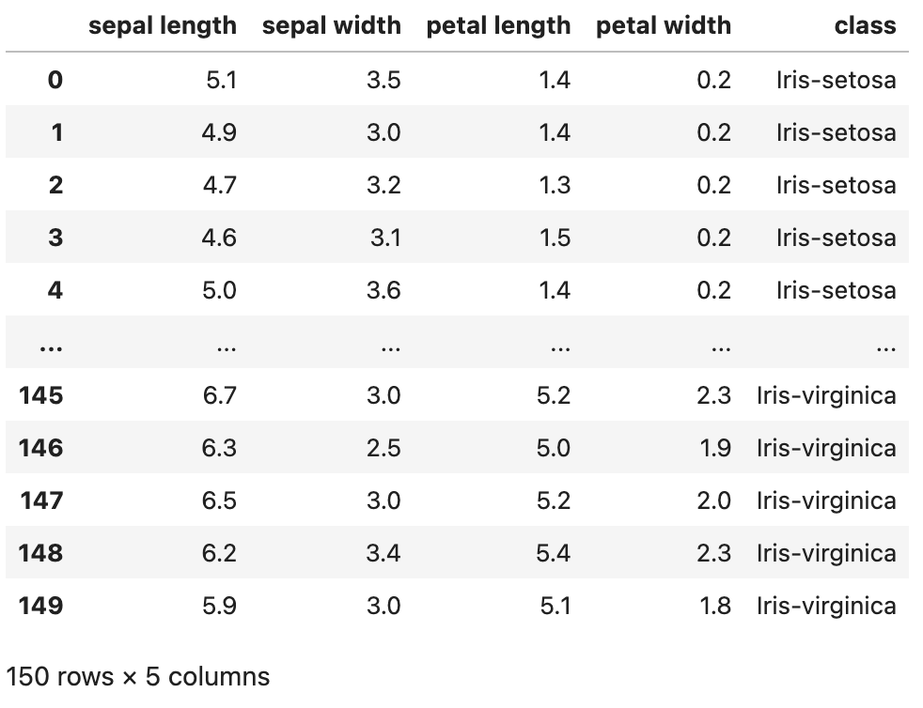

sns.boxplot(x='class',y='sepal length',data=df)
plt.show()
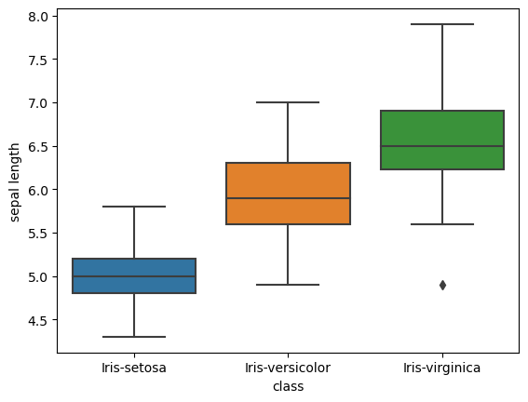
sns.boxplot(x='class',y='sepal width',data=df)
plt.show()
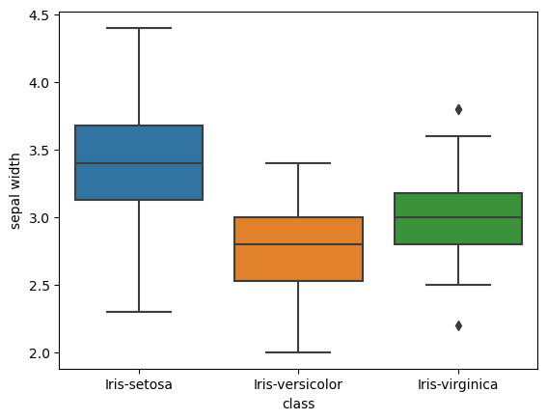
sns.boxplot(x='class',y='petal length',data=df)
plt.show()
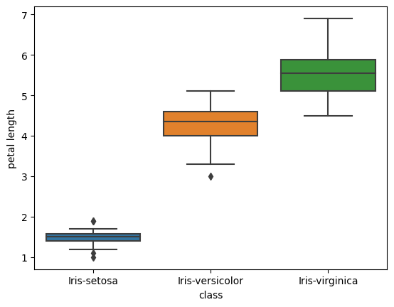
sns.boxplot(x='class',y='sepal width',data=df)
plt.show()

sns.histplot(x='sepal length',data=df)
plt.show()
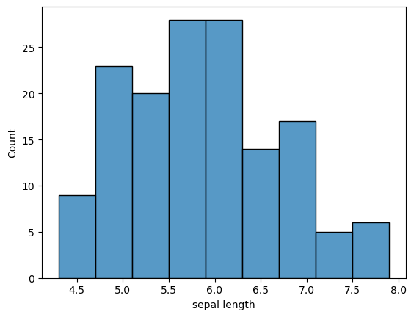
df.plot(kind='scatter',x='petal length',y='sepal length')
plt.grid()
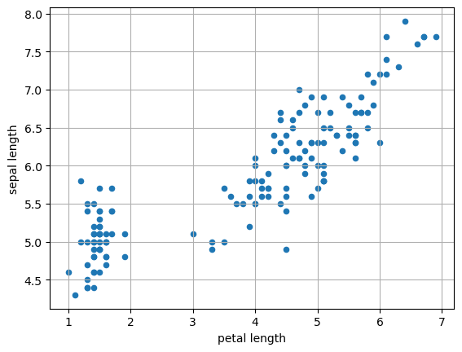
sns.scatterplot(x='petal length',y='sepal length',data=df,marker='+')
<Axes: xlabel='petal length', ylabel='sepal length'>
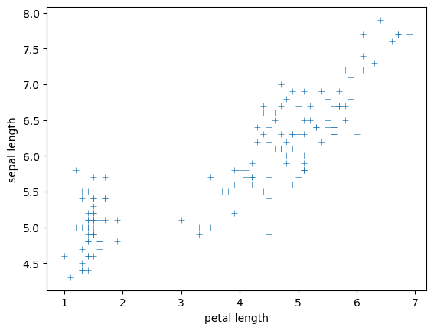
sns.pairplot(df)
<seaborn.axisgrid.PairGrid at 0x22ffa2af550>
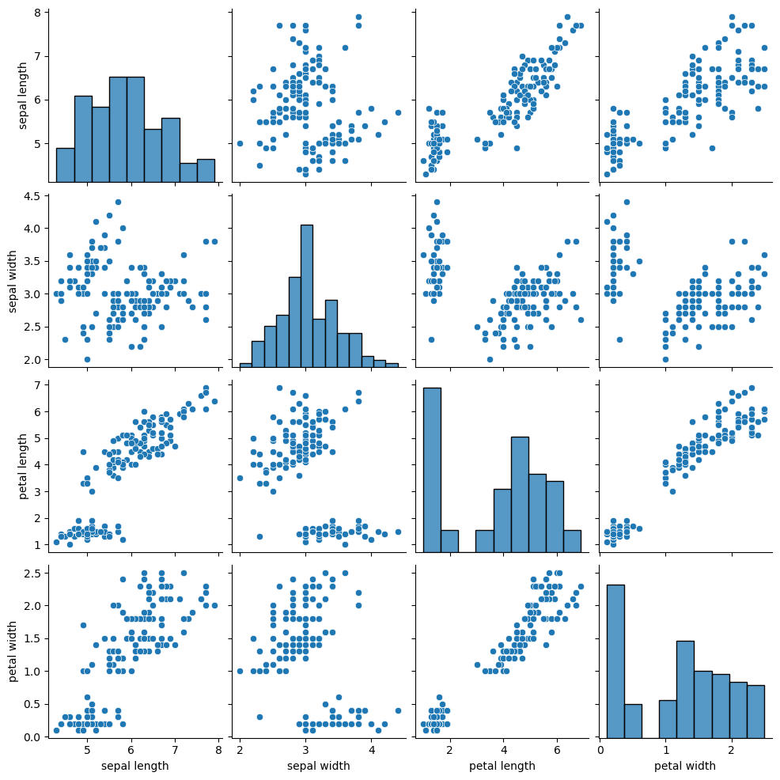

Week No: 4 | Roll Number: 23071A05B0 | Date: 3|2|26
Week 4 Title: Data Preprocessing Techniques
Aim: To implement Data preprocessing Techniques
Program/Output:
import pandas as pd
import matplotlib.pyplot as plt
import seaborn as sns
from statistics import median
import numpy as np
df=pd.read_csv('D:\\VJIET2022\\DE Lab_2-2-2023-24\\AIML C\\auto-mpg.csv')
df
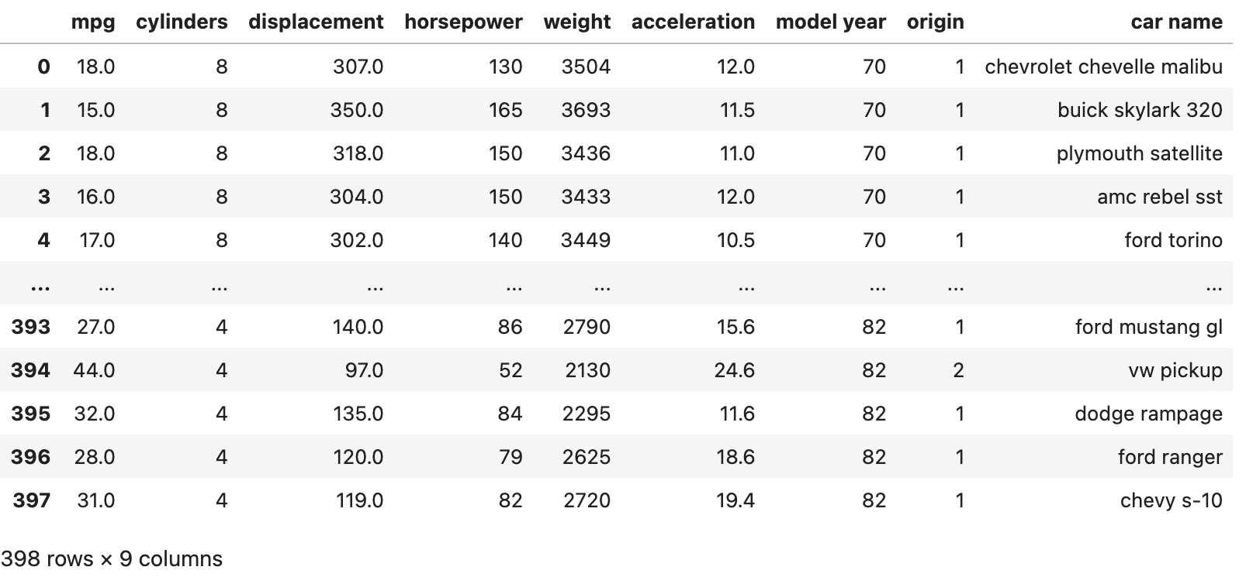
sns.boxplot(x='mpg',data=df)
<Axes: xlabel='mpg'>
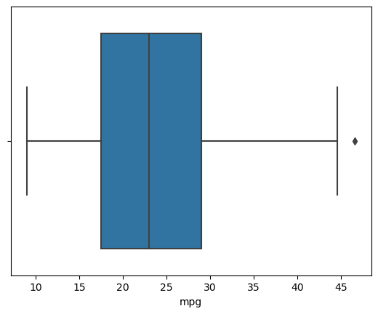
dummy=df.loc[df['horsepower']=='?']
dummy
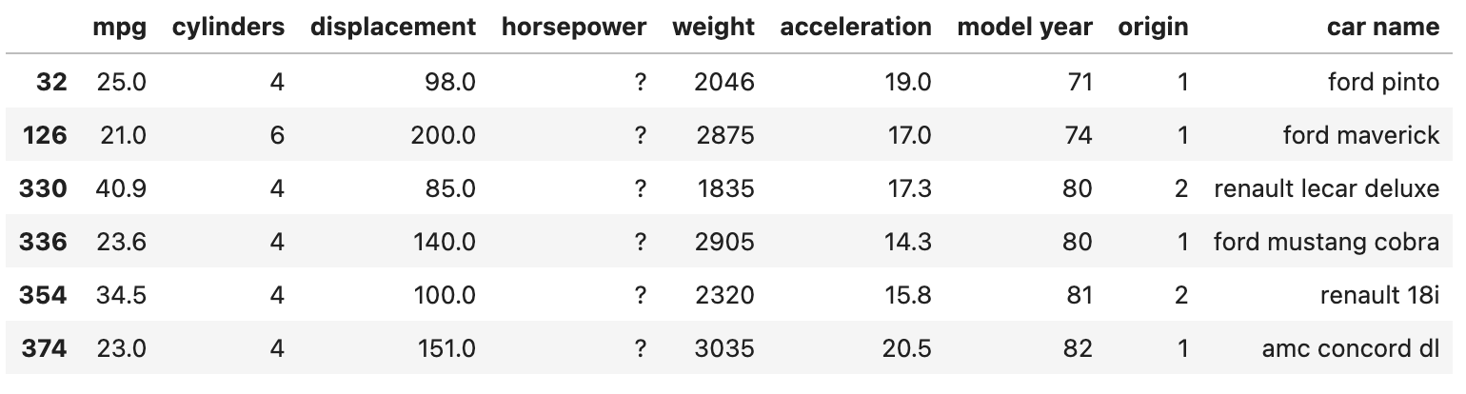
# converting a column into an array
arr= df['horsepower'].values
arr
array(['130', '165', '150', '150', '140', '198', '220', '215', '225',
'190', '170', '160', '150', '225', '95', '95', '97', '85', '88',
'46', '87', '90', '95', '113', '90', '215', '200', '210', '193',
'88', '90', '95', '?', '100', '105', '100', '88', '100', '165',
...
'85', '92', '112', '96', '84', '90', '86', '52', '84', '79', '82'],
dtype=object)

df.isnull().sum()
mpg 0
cylinders 0
displacement 0
horsepower 0
weight 0
acceleration 0
model year 0
origin 0
car name 0
dtype: int64

# replace "?" to NaN
df.replace("?", np.nan, inplace = True)
df.head(5)
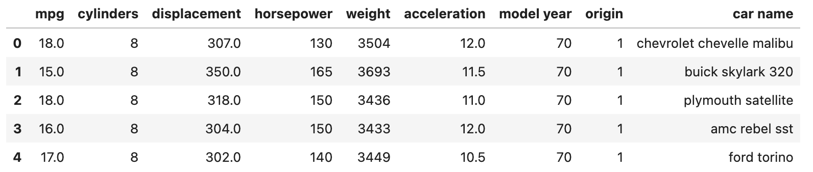

# calculate q1 (first quartile) and Q3(Third quartile).
q1=df.mpg.quantile(0.25)
q3=df.mpg.quantile(0.75)
#Calculate IQR
IQR=q3-q1
IQR
11.5

#calculate lowerlimit and upper limit
LL=q1-1.5*IQR
UL=q3+1.5*IQR
UL
46.25

LL
0.25

#Upper bound
upper = np.where(df['mpg'] >= UL)
upper
(array([322], dtype=int64),)

#lower bound
lower = np.where(df['mpg']<=LL)
lower
(array([], dtype=int64),)

# delete the rows above upper and below lower values
df.drop(upper[0], inplace=True)
df
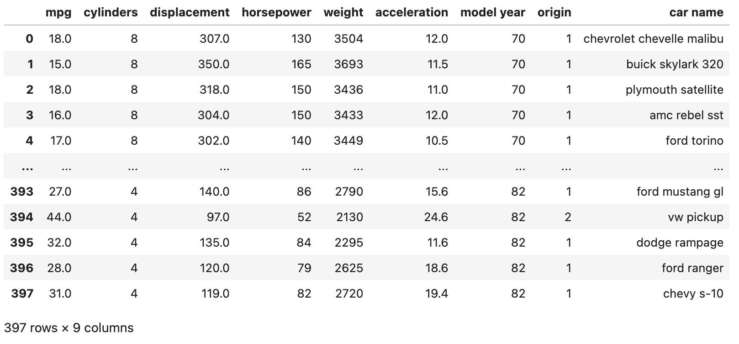
df.drop(lower[0], inplace=True)
df
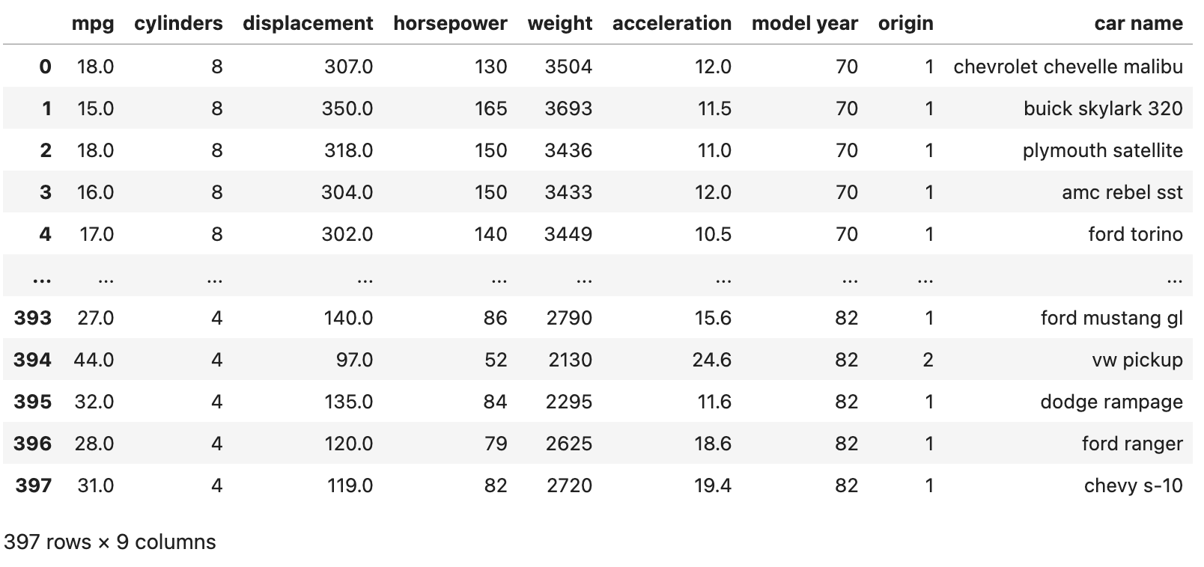
sns.boxplot(x='acceleration',data=df2)
<Axes: xlabel='acceleration'>
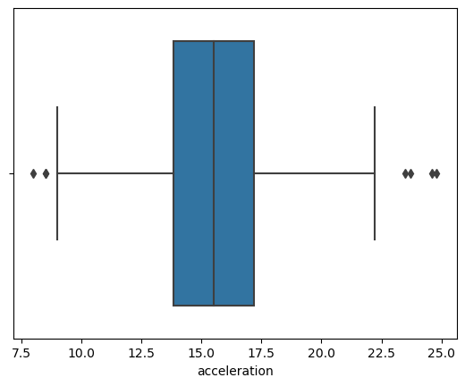
# Generate histogram for a specific feature
sns.histplot(x='acceleration',data=df2)
plt.show()
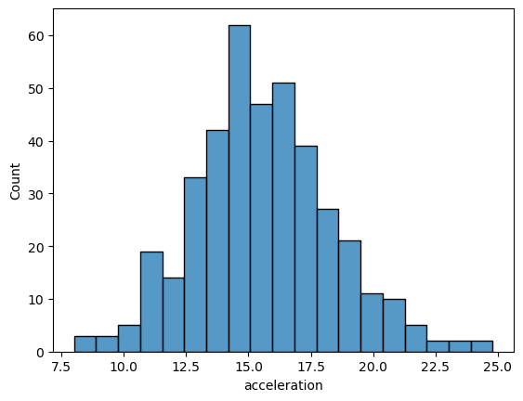

#Scatter plot
df.plot(kind="scatter",x='acceleration',y='mpg')
#plt.show()
plt.grid()
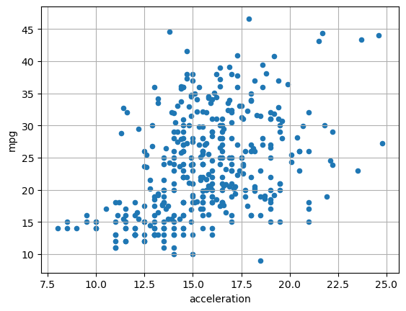
# IQR=q3-q1
q1=df2.acceleration.quantile(0.25)
q3=df2.acceleration.quantile(0.75)
IQR=q3-q1
IQR
LL=q1-1.5*IQR
UL=q3+1.5*IQR
UL
22.2

LL
8.8

upper = np.where(df2['acceleration'] > UL)
upper
(array([ 59, 299, 326, 394], dtype=int64),)

print(df2.loc[[326]])
mpg cylinders displacement horsepower weight acceleration \
326 43.4 4 90.0 48 2335 23.7

model year origin car name
326 80 2 vw dasher (diesel)

lower = np.where(df2['acceleration'] < LL)
lower
(array([ 7, 9, 11], dtype=int64),)

med=df2['acceleration'].quantile(0.50)
med
15.5

# indexing method
# first convert the target values into an array
arr= df2['acceleration'].values
arr
array([12. , 11.5, 11. , 12. , 10.5, 10. , 9. , 8.5, 10. , 8.5, 10. ,
8. , 9.5, 10. , 15. , 15.5, 15.5, 16. , 14.5, 20.5, 17.5, 14.5,
...
16.2, 16.4, 17. , 14.5, 14.7, 13.9, 13. , 17.3, 15.6, 24.6, 11.6,
18.6, 19.4])

# if arr values are in between ll and ul, represent that
# value as True else as False
# False values are outliers we can find it at 5th position
true_index = (arr>LL) & (arr < UL)
true_index
# Outliers are represented as False
rray([ True, True, True, True, True, True, True, False, True,
False, True, False, True, True, True, True, True, True,
...
True, True, True, True, True, True, True, False, True,
True, True])

# let us substitute mean value in the place of outliers
# so ca1culate mean of all values other than the outliers.
mid1=np.mean(df2['acceleration'][true_index])
mid1
15.501542416452441
#replace False index value by mean
false_index= ~true_index # ~ is bool operator for inverse
df2['acceleration'].values[false_index]=mid1
df2
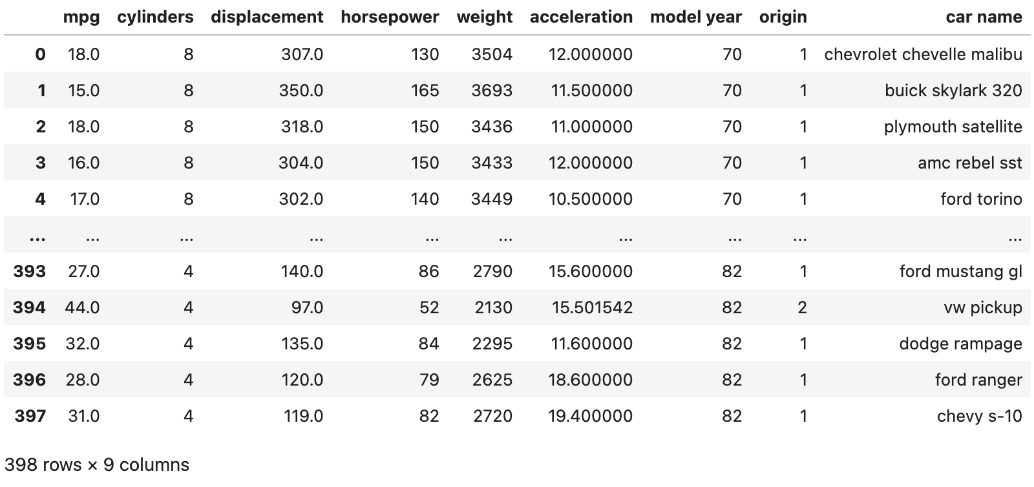
print(np.where(df2['acceleration'] > UL))
(array([], dtype=int64),)

df1=pd.read_csv('D:\\VJIET2022\\DE Lab_2-2-2023-24\\AIML C\\auto-mpg.csv')
df1
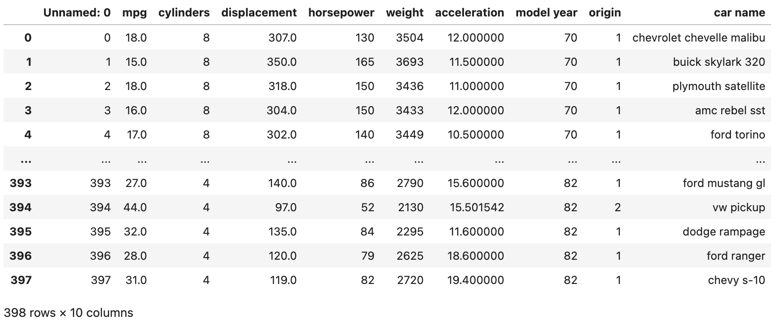

df1.shape
(398, 10)

sns.boxplot(x='mpg',data=df1)
<Axes: xlabel='mpg'>

#Identify outliers in cylinders
max_threshold=df1['acceleration'].quantile(0.95)
min_threshold=df1['acceleration'].quantile(0.05)
max_threshold
19.514999999999997

min_threshold
11.485

# displaying outlier index values
upper[0]
array([ 59, 299, 326, 394], dtype=int64)

#displaying outlier from dataest using index value
print(df1.loc[[59]])
Unnamed: 0 mpg cylinders displacement horsepower weight \
59 59 23.0 4 97.0 54 2254

acceleration model year origin car name
59 15.501542 72 2 volkswagen type 3

sns.boxplot(x='mpg',data=df1)
<Axes: xlabel='mpg'>


Week No: 5 | Roll Number: 23071A05B0 | Date: 3|2|26
Week 5 Title: Feature Construction
Aim: To implement Feature Construction Techniques
Program/Output:
import pandas as pd
import matplotlib.pyplot as plt
import seaborn as sns
df=pd.read_csv('D:\\VJIET2022\\DE Lab_3-2-2026\\CSE B\\homeprices.csv')
df
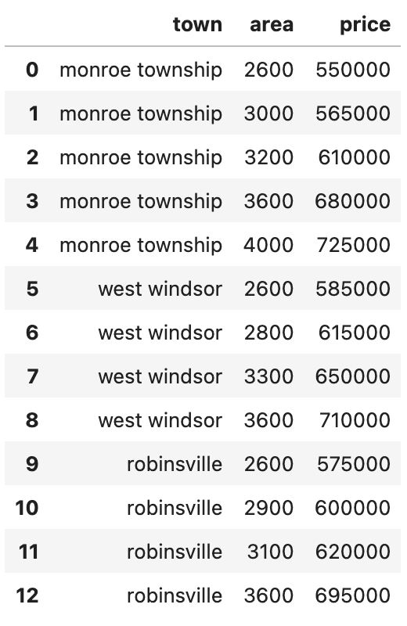
#1. Dummy coding categorical(nominal) variables.
#Using pandas to create dummy variables
dummies = pd.get_dummies (df.town)
dummies

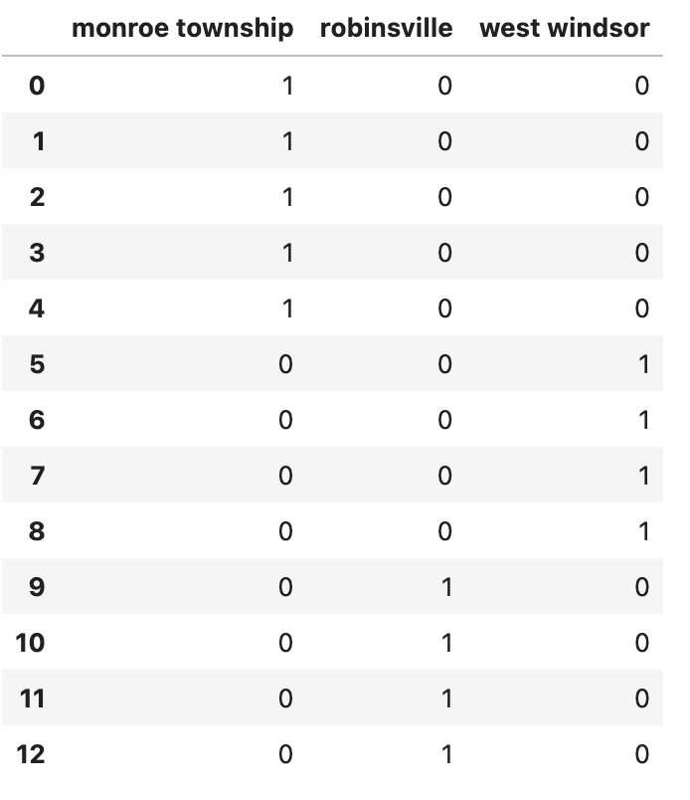
#to avoid dummpy variable trap, remove one column
dummies = dummies.drop(['west windsor'], axis='columns')
dummies
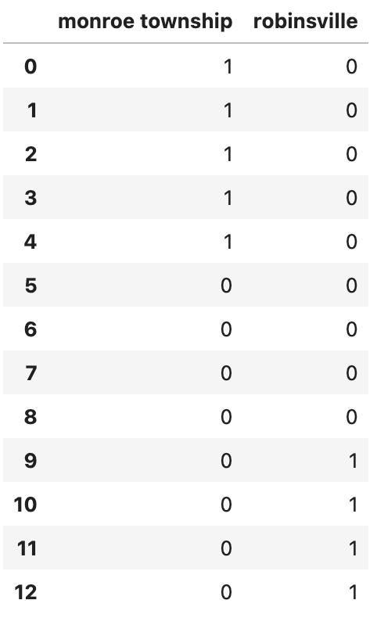
#add these dummies to original df. add olumns of ho.
merged = pd.concat ([df, dummies], axis='columns')
#we do dummy var not require 'town variable as Tt Is replaced h
#Hence drop town.
final= merged.drop(['town'], axis='columns')
final
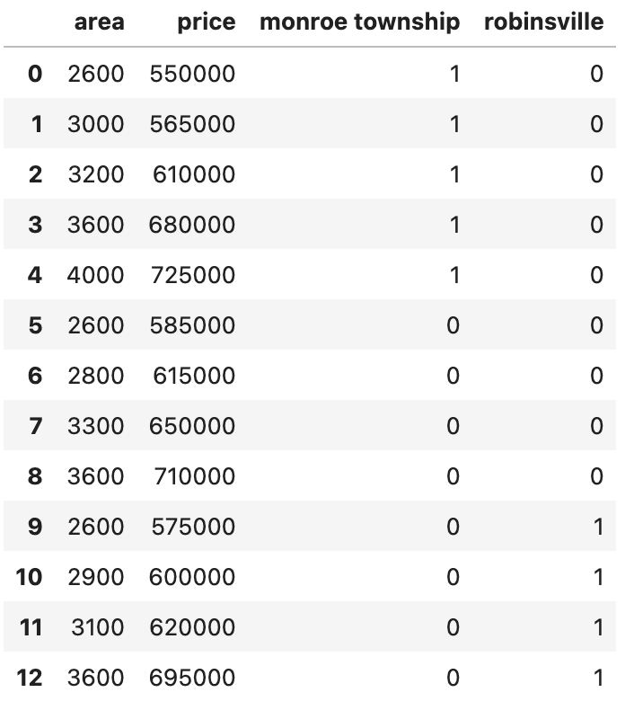
#Another method of encoding categorical(nominal) variables using "one hot encoding"
from sklearn.preprocessing import OneHotEncoder
ohe= OneHotEncoder (handle_unknown="ignore")
X1=ohe. fit_transform(df[['town']])
X1=pd.DataFrame (X1.toarray())
#Droping one column
X1 = X1.iloc[:, 1:]
X1
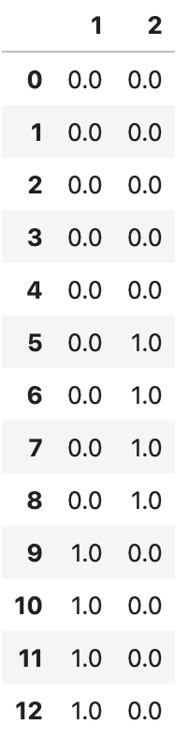
#Encoding categorical(ordinal) variables(Using Label encoder)
import pandas as pd
iris= pd.read_csv('D:\\VJIET2022\\DE Lab_2-2-2023-24\\AIML C\\Iris.csv')
iris
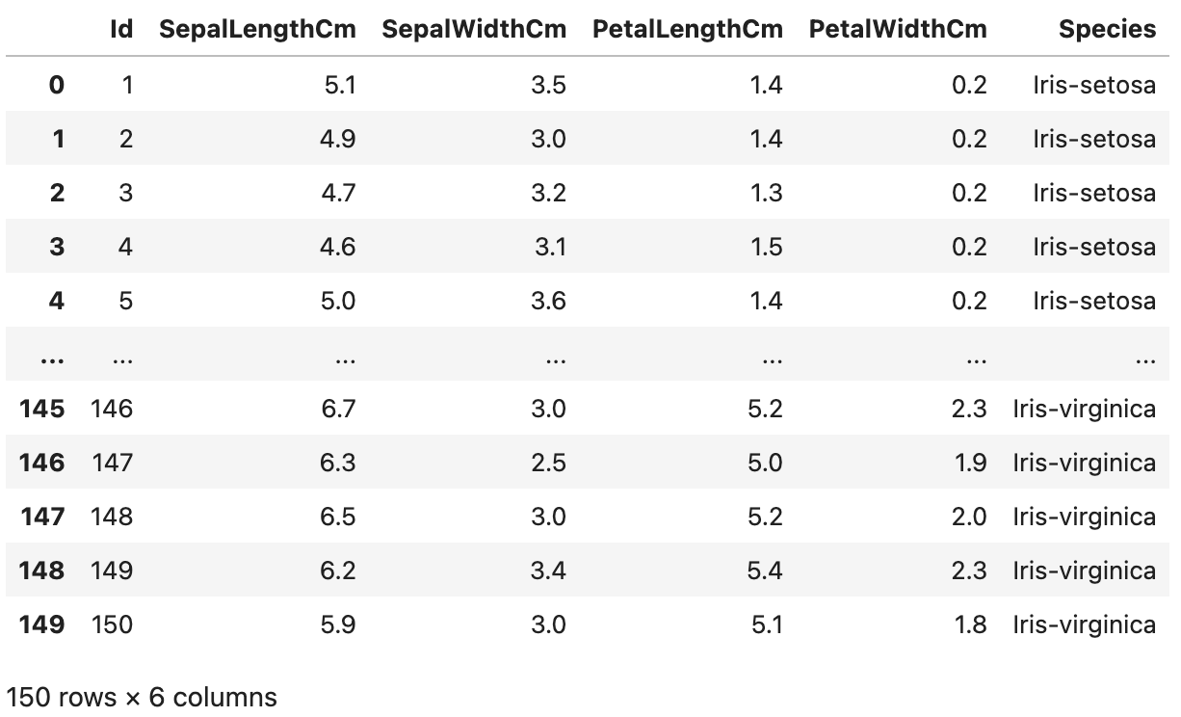

#Label encoding of nominal data using sklearn
from sklearn.preprocessing import LabelEncoder
le=LabelEncoder()
iris_1=iris
iris_1.Species=le.fit_transform(iris_1.Species)
iris_1
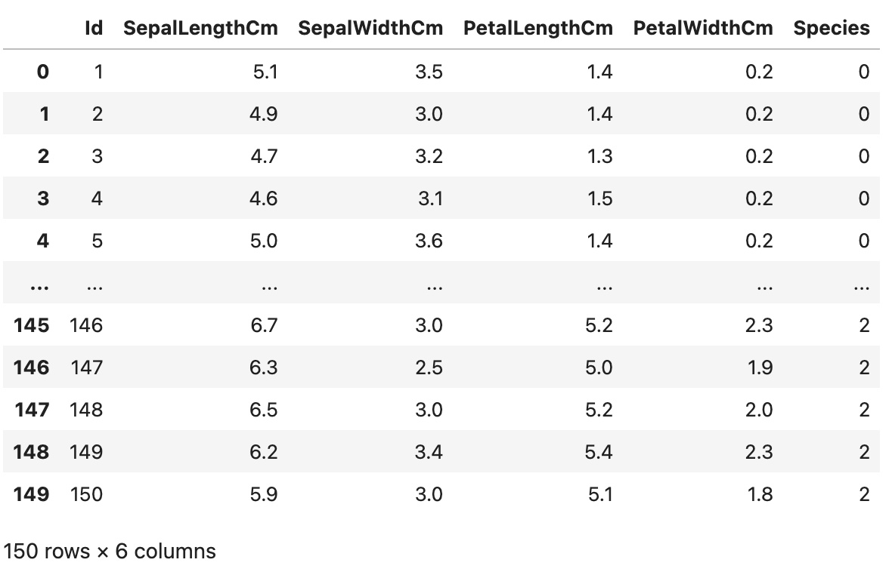
#3. Transforming numeric(continuous)features to categorical features
import matplotlib.pyplot as plt
plt.hist(iris.PetalWidthCm,edgecolor="w")
plt.show()
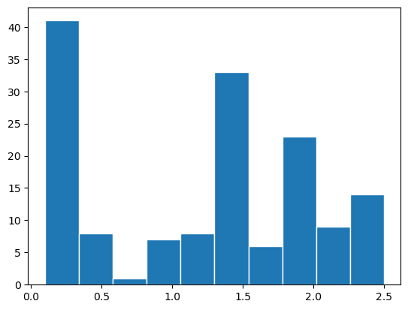
iris['petal_category']=pd.cut(iris.PetalWidthCm ,bins=[0,1,2,2.5])
print(iris['petal_category'])
0 (0.0, 1.0]
1 (0.0, 1.0]
2 (0.0, 1.0]
3 (0.0, 1.0]
4 (0.0, 1.0]
...
145 (2.0, 2.5]
146 (1.0, 2.0]
147 (1.0, 2.0]
148 (2.0, 2.5]
149 (1.0, 2.0]
Name: petal_category, Length: 150, dtype: category
Categories (3, interval[float64, right]): [(0.0, 1.0] < (1.0, 2.0] < (2.0, 2.5]]

print(iris['petal_category'].value_counts())
(1.0, 2.0] 70
(0.0, 1.0] 57
(2.0, 2.5] 23
Name: petal_category, dtype: int64

#2. Encoding categorical(ordinal) variables
from sklearn.preprocessing import OrdinalEncoder
encoder=OrdinalEncoder()
iris['petal_category']=encoder.fit_transform(iris[['petal_category']])
iris
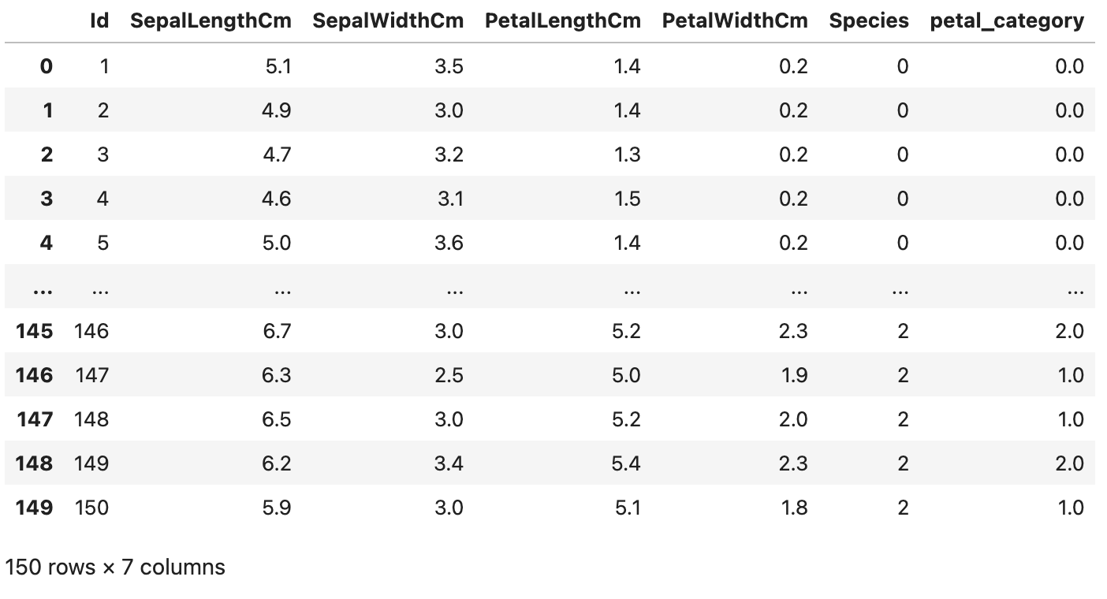

Week No: 6 | Roll Number: 23071A05B0 | Date: 3|2|26
Week 6 Title: Feature Construction
Aim: To implement Feature Construction Techniques
Program/Output:
import pandas as pd
import matplotlib.pyplot as plt
import seaborn as sns
from sklearn import datasets
from sklearn.decomposition import PCA
import sklearn.preprocessing
df=datasets.load_iris()
df
{'data': array([[5.1, 3.5, 1.4, 0.2],
[4.9, 3. , 1.4, 0.2],
...
[6.5, 3. , 5.2, 2. ],
[6.2, 3.4, 5.4, 2.3],
[5.9, 3. , 5.1, 1.8]]),

#1. Principal Component Analysis (PCA)
#Determining initial dimensions of dataset
x=df.data
y=df.target
print(x.shape,y.shape)
(150, 4) (150,)

#scatter plot
plt.scatter(x[:,0],x[:,1],c=y)
<matplotlib.collections.PathCollection at 0x1b825612f80>
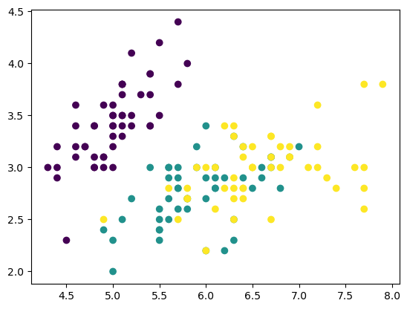
from sklearn.decomposition import PCA
pca = PCA()
X_new = pca.fit_transform(x)
cov_mat=pca.get_covariance()
import numpy as np
eig_vals, eig_vecs=np.linalg.eig(cov_mat)
#PCA for tagrget dimension on the dataset
pca=PCA(n_components=2)
pca.fit(x)
# Visualizing principle components
pca.components_
array([[ 0.36138659, -0.08452251, 0.85667061, 0.3582892 ],
[ 0.65658877, 0.73016143, -0.17337266, -0.07548102]])
# Transforming the dataset from 4 dimensions into 2 dimension using PCA
z=pca.transform(x)
z.shape
(150, 2)

#scatter plot
plt.scatter(z[:,0],z[:,1],c=y)
<matplotlib.collections.PathCollection at 0x1b829284df0>
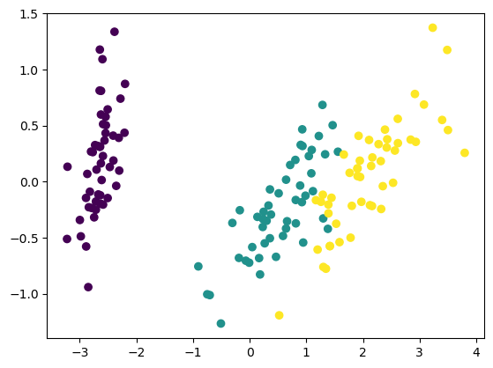
# Variance ratio of the target dimensions
pca.explained_variance_ratio_
array([0.92461872, 0.05306648])

#0.4 Singular Value Decomposition
iris1 = sklearn.datasets.load_iris()
iris1.data.shape
(150, 4)

df_iris = pd.DataFrame(iris1.data, columns=iris1.feature_names)
df_iris.shape
(150, 4)

U_iris, S_iris, Vt_iris = np.linalg.svd(df_iris, full_matrices=False)
U_iris.shape
(150, 4)

S_iris
array([95.95991387, 17.76103366, 3.46093093, 1.88482631])

Vt_iris
array([[-0.75110816, -0.38008617, -0.51300886, -0.16790754],
[ 0.2841749 , 0.5467445 , -0.70866455, -0.34367081],
[ 0.50215472, -0.67524332, -0.05916621, -0.53701625],
[ 0.32081425, -0.31725607, -0.48074507, 0.75187165]])

#Befroe SVD scatter plot
x=iris1.data
y=iris1.target
print(x.shape,y.shape)
#scatter plot
plt.scatter(x[:,0],x[:,1],c=y)
(150, 4) (150,)
<matplotlib.collections.PathCollection at 0x1b8292f37c0>

# After SVD
import matplotlib.pyplot as plt
# Plot the first two columns of U
plt.scatter(U_iris[:, 0], U_iris[:, 1], c=iris1.target)
plt.xlabel('PC1')
plt.ylabel('PC2')
plt.show()
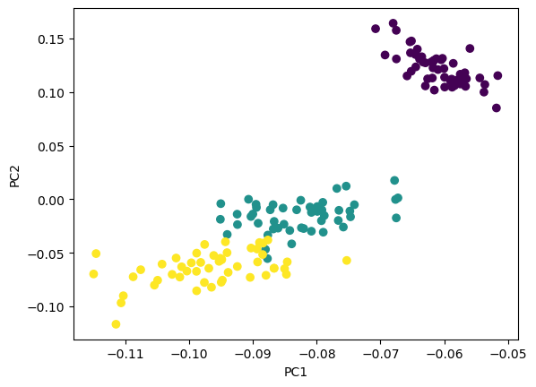
#3.Linear Discriminant Analysis (LDA)
#determing the initial dimensions of the dataset
X=df.data
Y=df.target
# DEcomposing 4D into 2D ising LDA
from sklearn.discriminant_analysis import LinearDiscriminantAnalysis
lda=LinearDiscriminantAnalysis(n_components=2)
X_r2=lda.fit(X,Y).transform(X)
#Getting the variance ratio
lda.explained_variance_ratio_
array([0.9912126, 0.0087874])
# visualizing 2D datab in the form of scatter plot
import numpy as np
colors=['royalblue','red','tan']
vectorizer=np.vectorize(lambda X:colors[X%len(colors)])
plt.scatter(X_r2[:,0],X_r2[:,1],c=vectorizer(y))
<matplotlib.collections.PathCollection at 0x1b8293ffe50>
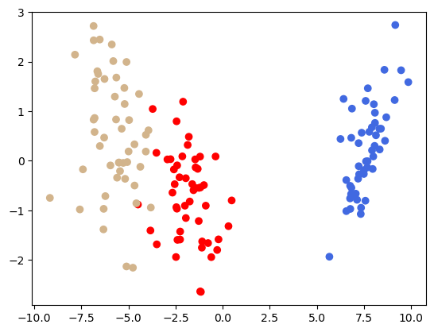
# Feature Subset Selection
iris= pd.read_csv('D:\\VJIET2022\\DE Lab_2-2-2023-24\\AIML C\\Iris.csv')
iris
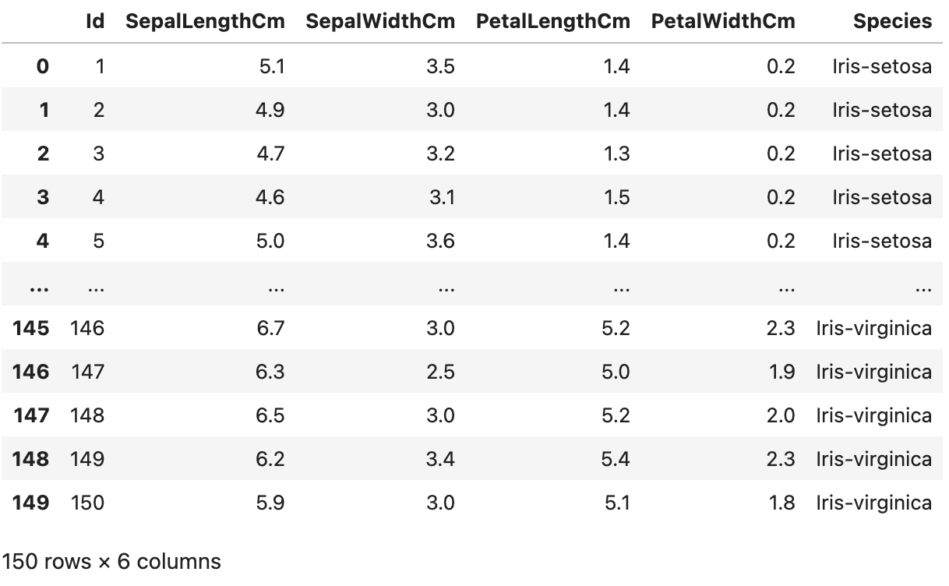
# Visualizing using pair plot
sns.pairplot(iris.drop(['Id'],axis=1),hue='Species',height=2)
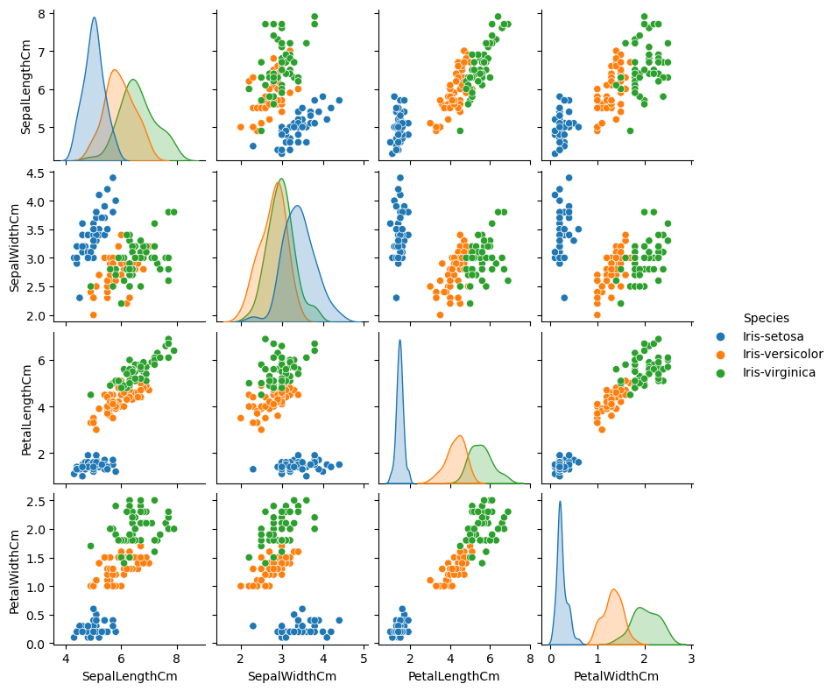

#Visualizing correlation using heatmap
sns.heatmap(iris.corr(method='pearson').drop(['Id'],axis=1).drop(['Id'],axis=0),annot=True)
plt.show()
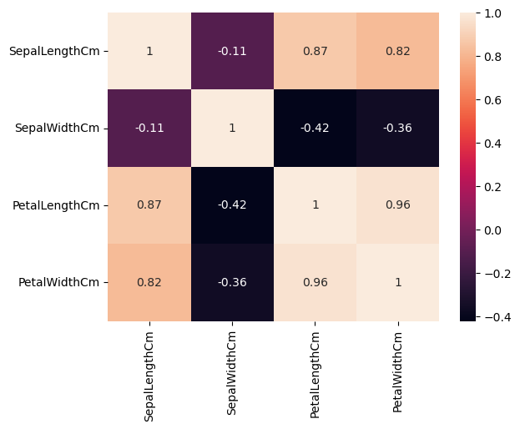

Week No: 7 | Roll Number: 23071A05B0 | Date: 17|3|26
Week 7 Title: Hadoop Lab Experiment
Aim: To learn basic HDFS commands for creating directories, transferring files between the
local Linux system and HDFS, viewing file contents, and retrieving files from HDFS.

Program/Output:
​​Step 1: Start Hadoop Services
nihaldastagiri@Nihals-MacBook-Pro ~ % start-dfs.sh
Starting namenodes on [localhost]
Starting datanodes
Starting secondary namenodes [Nihals-MacBook-Pro.local]

nihaldastagiri@Nihals-MacBook-Pro ~ % start-yarn.sh
Starting resourcemanager
Starting nodemanagers

nihaldastagiri@Nihals-MacBook-Pro ~ % jps
47872 NodeManager
47443 DataNode
47940 Jps
47579 SecondaryNameNode
47771 ResourceManager
47340 NameNode

Step 2: Create Directory in HDFS
nihaldastagiri@Nihals-MacBook-Pro ~ % hdfs dfs -mkdir /hadooplab

nihaldastagiri@Nihals-MacBook-Pro ~ % hdfs dfs -mkdir /hadooplab/input

nihaldastagiri@Nihals-MacBook-Pro ~ % hdfs dfs -ls /
Found 1 items
drwxr-xr-x - nihaldastagiri supergroup 0 2026-03-30 16:56 /hadooplab

Step 3: Create Local File Using Linux Command
nihaldastagiri@Nihals-MacBook-Pro ~ % echo "Welcome to Hadoop Lab Experiment" > sample.txt
nihaldastagiri@Nihals-MacBook-Pro ~ % cat sample.txt
Welcome to Hadoop Lab Experiment

Step 4: Upload File from Local System to HDFS
nihaldastagiri@Nihals-MacBook-Pro ~ % hdfs dfs -put sample.txt /hadooplab/input

Step 5: View Files in HDFS Directory
nihaldastagiri@Nihals-MacBook-Pro ~ % hdfs dfs -ls /hadooplab/input
Found 1 items
-rw-r--r-- 1 nihaldastagiri supergroup 33 2026-03-30 16:58 /hadooplab/input/sample.txt

Step 6: View File Contents Stored in HDFS
nihaldastagiri@Nihals-MacBook-Pro ~ % hdfs dfs -cat /hadooplab/input/sample.txt
Welcome to Hadoop Lab Experiment

Step 7: Retrieve File from HDFS to Local Disk
nihaldastagiri@Nihals-MacBook-Pro ~ % hdfs dfs -copyToLocal /hadooplab/input/sample.txt

Week No: 8 & 9 | Roll Number: 23071A05B0 | Date: 24|3|26
Week 8 & 9 Title: Map Reduce Programming
Aim: To implement the word count program using hadoop and java

Program/Output:
​​Step 1: Creating directories
nihaldastagiri@Nihals-MacBook-Pro ~ % mkdir mapreduce
nihaldastagiri@Nihals-MacBook-Pro ~ % cd mapreduce
nihaldastagiri@Nihals-MacBook-Pro mapreduce % mkdir classes

Step 2: Make the WordCount.java file
nihaldastagiri@Nihals-MacBook-Pro mapreduce % nano WordCount.java
nihaldastagiri@Nihals-MacBook-Pro mapreduce % cat WordCount.java
import java.io.IOException;
import java.util.StringTokenizer;

import org.apache.hadoop.conf.Configuration;
import org.apache.hadoop.fs.Path;

import org.apache.hadoop.io.IntWritable;
import org.apache.hadoop.io.Text;

import org.apache.hadoop.mapreduce.Job;
import org.apache.hadoop.mapreduce.Mapper;
import org.apache.hadoop.mapreduce.Reducer;

import org.apache.hadoop.mapreduce.lib.input.FileInputFormat;
import org.apache.hadoop.mapreduce.lib.output.FileOutputFormat;

public class WordCount {

public static class TokenizerMapper
extends Mapper<Object, Text, Text, IntWritable> {

private static final IntWritable one = new IntWritable(1);
private Text word = new Text();

public void map(Object key, Text value, Context context)
throws IOException, InterruptedException {

StringTokenizer itr = new StringTokenizer(value.toString());

while (itr.hasMoreTokens()) {
word.set(itr.nextToken());
context.write(word, one);
}
}
}

public static class IntSumReducer
extends Reducer<Text, IntWritable, Text, IntWritable> {

private IntWritable result = new IntWritable();

public void reduce(Text key, Iterable<IntWritable> values,
Context context)
throws IOException, InterruptedException {

int sum = 0;

for (IntWritable val : values) {
sum += val.get();
}

result.set(sum);
context.write(key, result);
}
}

public static void main(String[] args) throws Exception {

Configuration conf = new Configuration();
Job job = Job.getInstance(conf, "word count");

job.setJarByClass(WordCount.class);
job.setMapperClass(TokenizerMapper.class);
job.setCombinerClass(IntSumReducer.class);
job.setReducerClass(IntSumReducer.class);

job.setOutputKeyClass(Text.class);
job.setOutputValueClass(IntWritable.class);

FileInputFormat.addInputPath(job, new Path(args[0]));
FileOutputFormat.setOutputPath(job, new Path(args[1]));

System.exit(job.waitForCompletion(true) ? 0 : 1);
}
}

Step 3: Compile the java file
nihaldastagiri@Nihals-MacBook-Pro mapreduce % javac -classpath `hadoop classpath` -d classes WordCount.java
nihaldastagiri@Nihals-MacBook-Pro mapreduce % ls classes
WordCount.class WordCount$IntSumReducer.class WordCount$TokenizerMapper.class

Step 4: Create JAR file
nihaldastagiri@Nihals-MacBook-Pro mapreduce % jar -cvf wordcount.jar -C classes/ .
added manifest
adding: WordCount$IntSumReducer.class(in = 1793) (out= 776)(deflated 56%)
adding: WordCount$TokenizerMapper.class(in = 1790) (out= 793)(deflated 55%)
adding: WordCount.class(in = 1511) (out= 832)(deflated 44%)
nihaldastagiri@Nihals-MacBook-Pro mapreduce % jar -tf wordcount.jar
META-INF/
META-INF/MANIFEST.MF
WordCount$IntSumReducer.class
WordCount$TokenizerMapper.class
WordCount.class

Step 5: Create the input file
nihaldastagiri@Nihals-MacBook-Pro mapreduce % nano count.txt
nihaldastagiri@Nihals-MacBook-Pro mapreduce % cat count.txt
hello world hello hadoop mapreduce hadoop

Step 6: Run the MapReduce job
nihaldastagiri@Nihals-MacBook-Pro mapreduce % hadoop jar wordcount.jar WordCount count.txt output
nihaldastagiri@Nihals-MacBook-Pro mapreduce % cat output/part-r-00000
hadoop 2
hello 2
mapreduce 1
world 1

Week No: 10 & 11 | Roll Number: 23071A05B0 | Date: 24|3|26
Week 10 & 11 Title: Hive
Aim: To understand Data Processing Tool – Hive and HQL (Hive query language)
Program/Output:
Step 1: Enter Hive Shell
nihaldastagiri@Nihals-MacBook-Pro ~ % docker exec -it hive-server /bin/bash
root@48d784308050:/opt# hive
Logging initialized using configuration in file:/opt/hive/conf/hive-log4j2.properties
hive>

Step 2: Create Database
hive> show databases;
OK
default
Time taken: 0.21 seconds
hive> create database emp_details;
hive> use emp_details;
hive> create database emp_details;
hive> use emp_details;
OK
Time taken: 0.08 seconds

Step 3: Create Managed Table
hive> create table emp(
empno int,
ename string,
job string,
sal int,
deptno int
) row format delimited fields terminated by ',';
OK
Time taken: 0.32 seconds

Step 4: Load Data from Local
hive> LOAD DATA LOCAL INPATH '/root/empdetails.txt'
OVERWRITE INTO TABLE emp;
Loading data to table emp_details.emp
OK
Time taken: 0.45 seconds

Step 5: View Data
hive> select * from emp;
1 A clerk 4000 10
2 A clerk 4000 30
3 B mgr 8000 20
4 C peon 2000 40
5 D clerk 4000 10
6 E mgr 8000 50
Time taken: 0.27 seconds

Step 5: Describe Table
hive> describe emp;
empno int
ename string
job string
sal int
deptno int

Step 7: Show Tables
hive> show tables;
OK
emp
Time taken: 0.18 seconds

Step 8: Select ename
hive> select ename from emp;
A
A
B
C
D
E

Step 9: Filter Records
hive> select * from emp where ename='A';
1 A clerk 4000 10
2 A clerk 4000 30

Step 10: Count Records
hive> select count(*) from emp;
6

Step 11: Group By
hive> select deptno, sum(sal) from emp group by deptno;
10 8000
20 8000
30 4000
40 2000
50 8000

Step 12: Salary Range
hive> select * from emp where sal between 1000 and 2000;
4 C peon 2000 40

Step 13: LIKE Query
hive> alter table emp add columns(lastname string);
OK

Step 14: List employee names where job has ‘l’ as second character
hive> select ename from emp where job LIKE '_l%';
A
A
D

Step 15: Retrieve total salary for each department
hive> select deptno, sum(sal) from emp group by deptno;
10 8000
20 8000
30 4000
40 2000
50 8000

Step 16: Add Column
hive> alter table emp add columns(lastname string);
OK

Step 17: Rename Table
hive> alter table emp rename to emp1;
OK

Step 18: Drop Table
hive> drop table emp1;
OK

Step 19: External Table
hive> create external table ext1(a int, b int, c int)
row format delimited
fields terminated by ','
location '/root/hivedata';
OK
hive> select * from ext1;
1 2 3
4 5 6

Step 20: Movies Dataset
hive> create database movies;
hive> use movies;
hive> create table movie_details(
no int,
name string,
year int,
rating float,
views int
)
row format delimited
fields terminated by ',';

Step 21: Movie Queries
hive> select count(*) from movie_details;
100
hive> select max(rating) from movie_details;
9.5

PARTITIONING & BUCKETING
hive> create database shopping;
hive> use shopping;

Step 1: Create Table
hive> create table shopping1(
code int,
item_name string,
category string,
place string
)
row format delimited fields terminated by ',';

Step 2: Load Data
hive> LOAD DATA LOCAL INPATH '/root/shop.txt'
OVERWRITE INTO TABLE shopping1;

Step 3: Partition + Bucketing
hive> create table shopping3(
code int,
item_name string,
place string
)
partitioned by (category string)
clustered by (place) into 3 buckets
row format delimited
fields terminated by ','
stored as textfile;

Step 4: Insert Data
hive> from shopping1
insert overwrite table shopping3
partition(category)
select code, item_name, place, category;
OK
Time taken: 1.2 seconds

Step 5: Check Partitions (HDFS)
root@48d784308050:/opt# hadoop fs -ls /user/hive/warehouse/shopping.db/shopping3
Found 8 items
drwxrwxrwx - root supergroup 0 2026-04-14 12:10 /user/hive/warehouse/shopping.db/shopping3/category=HIVE_DEFAULT_PARTITION
drwxrwxrwx - root supergroup 0 2026-04-14 12:10 /user/hive/warehouse/shopping.db/shopping3/category=apparel
drwxrwxrwx - root supergroup 0 2026-04-14 12:10 /user/hive/warehouse/shopping.db/shopping3/category=bag
drwxrwxrwx - root supergroup 0 2026-04-14 12:10 /user/hive/warehouse/shopping.db/shopping3/category=cosmetic
drwxrwxrwx - root supergroup 0 2026-04-14 12:10 /user/hive/warehouse/shopping.db/shopping3/category=electronicgadget
drwxrwxrwx - root supergroup 0 2026-04-14 12:10 /user/hive/warehouse/shopping.db/shopping3/category=furnishing
drwxrwxrwx - root supergroup 0 2026-04-14 12:10 /user/hive/warehouse/shopping.db/shopping3/category=toys
drwxrwxrwx - root supergroup 0 2026-04-14 12:10 /user/hive/warehouse/shopping.db/shopping3/category=utensils

Step 6: Check Buckets
root@48d784308050:/opt# hadoop fs -ls /user/hive/warehouse/shopping.db/shopping3/category=utensils
000000_0
000001_0
000002_0

Week No: 12 & 13 | Roll Number: 23071A05B0 | Date: 31|3|26
Week 12 & 13 Title: MongoDB
Aim: To understand MongoDB queries.
Program/Output:
Create a database and explore basic database commands
Create a database
test> use 23071A05B0
switched to db 23071A05B0
23071A05B0> db
23071A05B0
23071A05B0> show dbs
admin 40.00 KiB
config 36.00 KiB
local 72.00 KiB
myDatabase 64.00 KiB
23071A05B0> db.Student.insert({"Name":"Pushikara"})
DeprecationWarning: Collection.insert() is deprecated. Use insertOne, insertMany, or bulkWrite.
{
acknowledged: true,
insertedIds: { '0': ObjectId('69de63fb54048a71e1f3417c') }
}
23071A05B0> show dbs
23071A05B0 40.00 KiB
admin 40.00 KiB
config 36.00 KiB
local 72.00 KiB
myDatabase 64.00 KiB

Drop Database
23071A05B0> db.dropDatabase()
{ ok: 1, dropped: '23071A05B0' }
23071A05B0> show dbs
admin 40.00 KiB
config 36.00 KiB
local 72.00 KiB
myDatabase 64.00 KiB

Step 3: Create Collection
23071A05B0> db.createCollection("Students")
{ ok: 1 }
23071A05B0> show collections
Students

Step 2: Drop Collection
23071A05B0> db.Students.drop()
true
23071A05B0> show collections

Create a database with sample dataset and work with MongoDB Query Language
Create Database:
23071A05B0> use emp
switched to db emp

Create Collection:
emp> db.createCollection("emp1")
{ ok: 1 }

Insert Records Into EMP1 Collection:
emp> db.emp1.insertMany([
| {no:1,name:"ST",salary:2000,role:"OB"},
| {no:2,name:"MSD",salary:1500,role:"WK"},
| {no:3,name:"YS",salary:1000,role:"ALR"},
| {no:4,name:"RD",salary:1000,role:"MOB"},
| {no:5,name:"RS",salary:500,role:"OB"},
| {no:6,name:"BK",salary:500,role:"MOB"},
| {no:7,name:"VK",salary:300,role:"BW"},
| {no:8,name:"JB",salary:400,role:"BW"},
| {no:9,name:"HP",salary:400,role:"ALR"},
| {no:10,name:"VS",salary:300,role:"OB"}
| ])
{
acknowledged: true,
insertedIds: {
'0': ObjectId('69de64de54048a71e1f3417d'),
'1': ObjectId('69de64de54048a71e1f3417e'),
'2': ObjectId('69de64de54048a71e1f3417f'),
'3': ObjectId('69de64de54048a71e1f34180'),
'4': ObjectId('69de64de54048a71e1f34181'),
'5': ObjectId('69de64de54048a71e1f34182'),
'6': ObjectId('69de64de54048a71e1f34183'),
'7': ObjectId('69de64de54048a71e1f34184'),
'8': ObjectId('69de64de54048a71e1f34185'),
'9': ObjectId('69de64de54048a71e1f34186')
}
}
Display Data in Proper Format:
emp> db.emp1.find().pretty()
[
{
_id: ObjectId('69de64de54048a71e1f3417d'),
no: 1,
name: 'ST',
salary: 2000,
role: 'OB'
},
{
_id: ObjectId('69de64de54048a71e1f3417e'),
no: 2,
name: 'MSD',
salary: 1500,
role: 'WK'
},
{
_id: ObjectId('69de64de54048a71e1f3417f'),
no: 3,
name: 'YS',
salary: 1000,
role: 'ALR'
},
{
_id: ObjectId('69de64de54048a71e1f34180'),
no: 4,
name: 'RD',
salary: 1000,
role: 'MOB'
},
{
_id: ObjectId('69de64de54048a71e1f34181'),
no: 5,
name: 'RS',
salary: 500,
role: 'OB'
},
{
_id: ObjectId('69de64de54048a71e1f34182'),
no: 6,
name: 'BK',
salary: 500,
role: 'MOB'
},
{
_id: ObjectId('69de64de54048a71e1f34183'),
no: 7,
name: 'VK',
salary: 300,
role: 'BW'
},
{
_id: ObjectId('69de64de54048a71e1f34184'),
no: 8,
name: 'JB',
salary: 400,
role: 'BW'
},
{
_id: ObjectId('69de64de54048a71e1f34185'),
no: 9,
name: 'HP',
salary: 400,
role: 'ALR'
},
{
_id: ObjectId('69de64de54048a71e1f34186'),
no: 10,
name: 'VS',
salary: 300,
role: 'OB'
}
]
Update Salary Of Employee where Name is "ST" by +8000
emp> db.emp1.updateOne(
| {name:"ST"},
| {$inc:{salary:8000}}
| )
{
acknowledged: true,
insertedId: null,
matchedCount: 1,
modifiedCount: 1,
upsertedCount: 0
}
Update Salary Of All Employee by giving an increment of +4000 each
emp> db.emp1.updateMany(
| {},
| {$inc:{salary:4000}}
| )
{
acknowledged: true,
insertedId: null,
matchedCount: 10,
modifiedCount: 10,
upsertedCount: 0
}

Update role of "MSD" as "C and WK"
emp> db.emp1.updateOne(
| {name:"MSD"},
| {$set:{role:"C and WK"}}
| )
{
acknowledged: true,
insertedId: null,
matchedCount: 1,
modifiedCount: 1,
upsertedCount: 0
}

Add a New Field remark to document with name "RS" set Remark as WC
emp> db.emp1.updateOne(
| {name:"RS"},
| {$set:{remark:"WC"}}
| )
{
acknowledged: true,
insertedId: null,
matchedCount: 1,
modifiedCount: 1,
upsertedCount: 0
}

Add a New Field As Number 11,name AK, Salary 10000,role coch without using insert statement.
emp> db.emp1.updateOne(
| {no:11},
| {$set:{name:"AK",salary:10000,role:"coach"}},
| {upsert:true}
| )
{
acknowledged: true,
insertedId: ObjectId('69de65baf25459187bffe5a8'),
matchedCount: 0,
modifiedCount: 0,
upsertedCount: 1
Remove added New Field (REMARK)
emp> db.emp1.updateOne(
| {name:"RS"},
| {$unset:{remark:""}}
| )
{
acknowledged: true,
insertedId: null,
matchedCount: 1,
modifiedCount: 1,
upsertedCount: 0
}

Update the Field "RD" by multiplying with salary by 2
emp> db.emp1.updateOne(
| {name:"RD"},
| {$mul:{salary:2}}
| )
{
acknowledged: true,
insertedId: null,
matchedCount: 1,
modifiedCount: 1,
upsertedCount: 0
}

To Find Document From the empl collection where name begins with S
emp> db.emp1.find({name:/^S/})
[
{
_id: ObjectId('69de64de54048a71e1f3417d'),
no: 1,
name: 'ST',
salary: 14000,
role: 'OB'
}
]

To Find Document From the empl collection where name begins with R
emp> db.emp1.find({name:/^R/})
[
{
_id: ObjectId('69de64de54048a71e1f34180'),
no: 4,
name: 'RD',
salary: 10000,
role: 'MOB'
},
{
_id: ObjectId('69de64de54048a71e1f34181'),
no: 5,
name: 'RS',
salary: 4500,
role: 'OB'
}
]

To Find Document From the empl collection where name ends with K
emp> db.emp1.find({name:/K$/})
[
{
_id: ObjectId('69de64de54048a71e1f34182'),
no: 6,
name: 'BK',
salary: 4500,
role: 'MOB'
},
{
_id: ObjectId('69de64de54048a71e1f34183'),
no: 7,
name: 'VK',
salary: 4300,
role: 'BW'
},
{
_id: ObjectId('69de65baf25459187bffe5a8'),
no: 11,
name: 'AK',
role: 'coach',
salary: 10000
}
]

To Find Document From the empl collection where name ends with D
emp> db.emp1.find({name:/D$/})
[
{
_id: ObjectId('69de64de54048a71e1f3417e'),
no: 2,
name: 'MSD',
salary: 5500,
role: 'C and WK'
},
{
_id: ObjectId('69de64de54048a71e1f34180'),
no: 4,
name: 'RD',
salary: 10000,
role: 'MOB'
}
]

Find Document From the empl collection where name has S in any position
emp> db.emp1.find({name:/S/})
[
{
_id: ObjectId('69de64de54048a71e1f3417d'),
no: 1,
name: 'ST',
salary: 14000,
role: 'OB'
},
{
_id: ObjectId('69de64de54048a71e1f3417e'),
no: 2,
name: 'MSD',
salary: 5500,
role: 'C and WK'
},
{
_id: ObjectId('69de64de54048a71e1f3417f'),
no: 3,
name: 'YS',
salary: 5000,
role: 'ALR'
},
{
_id: ObjectId('69de64de54048a71e1f34181'),
no: 5,
name: 'RS',
salary: 4500,
role: 'OB'
},
{
_id: ObjectId('69de64de54048a71e1f34186'),
no: 10,
name: 'VS',
salary: 4300,
role: 'OB'
}
]

Using Regular Expression
Find Document From the empl collection where name begins with S
emp> db.emp1.find({name:{$regex:"^S"}})
[
{
_id: ObjectId('69de64de54048a71e1f3417d'),
no: 1,
name: 'ST',
salary: 14000,
role: 'OB'
}
]

Find Document From the empl collection where name begins, ends and contains S
emp> db.emp1.find({name:{$regex:"S",$options:"i"}})
[
{
_id: ObjectId('69de64de54048a71e1f3417d'),
no: 1,
name: 'ST',
salary: 14000,
role: 'OB'
},
{
_id: ObjectId('69de64de54048a71e1f3417e'),
no: 2,
name: 'MSD',
salary: 5500,
role: 'C and WK'
},
{
_id: ObjectId('69de64de54048a71e1f3417f'),
no: 3,
name: 'YS',
salary: 5000,
role: 'ALR'
},
{
_id: ObjectId('69de64de54048a71e1f34181'),
no: 5,
name: 'RS',
salary: 4500,
role: 'OB'
},
{
_id: ObjectId('69de64de54048a71e1f34186'),
no: 10,
name: 'VS',
salary: 4300,
role: 'OB'
}
]

Display Documents where in empl collection Field have OB,MOB
emp> db.emp1.find({role:{$in:["OB","MOB"]}})
[
{
_id: ObjectId('69de64de54048a71e1f3417d'),
no: 1,
name: 'ST',
salary: 14000,
role: 'OB'
},
{
_id: ObjectId('69de64de54048a71e1f34180'),
no: 4,
name: 'RD',
salary: 10000,
role: 'MOB'
},
{
_id: ObjectId('69de64de54048a71e1f34181'),
no: 5,
name: 'RS',
salary: 4500,
role: 'OB'
},
{
_id: ObjectId('69de64de54048a71e1f34182'),
no: 6,
name: 'BK',
salary: 4500,
role: 'MOB'
},
{
_id: ObjectId('69de64de54048a71e1f34186'),
no: 10,
name: 'VS',
salary: 4300,
role: 'OB'
}
]

Display Documents where in empl collection Field not have OB,MOB
emp> db.emp1.find({role:{$nin:["OB","MOB"]}})
[
{
_id: ObjectId('69de64de54048a71e1f3417e'),
no: 2,
name: 'MSD',
salary: 5500,
role: 'C and WK'
},
{
_id: ObjectId('69de64de54048a71e1f3417f'),
no: 3,
name: 'YS',
salary: 5000,
role: 'ALR'
},
{
_id: ObjectId('69de64de54048a71e1f34183'),
no: 7,
name: 'VK',
salary: 4300,
role: 'BW'
},
{
_id: ObjectId('69de64de54048a71e1f34184'),
no: 8,
name: 'JB',
salary: 4400,
role: 'BW'
},
{
_id: ObjectId('69de64de54048a71e1f34185'),
no: 9,
name: 'HP',
salary: 4400,
role: 'ALR'
},
{
_id: ObjectId('69de65baf25459187bffe5a8'),
no: 11,
name: 'AK',
role: 'coach',
salary: 10000
}
]

